Stomp Rockets

Subject:  Related Subjects: | Grade Level(s):  Length of Lesson: | Type: Inquiry / Design / Project  Keywords:

Lesson Overview
Use this section to describe at a high level what the lesson is. Should be no more than 3-4 lines.

Lesson Focus
What is the central question or phenomenon being investigated? What problem are they trying to solve?

Lesson Objective(s) | By the end of this lesson, students will…  - Learn the concepts of attraction, repulsion, friction, polarity, and charge.

Lesson Timing

5 minutes | Introduce the Lesson
30 minutes | ...

Materials | - 2 – 1L or 2L bottles  - 20 – sheets of card stock paper  - 1 to 2 – rolls of masking tape  - 10 – scissors  - 12” – flexible pipe insulator (to be cut into two 6” pieces)  - 6’ – PVC pipe (to be cut into four 18” pieces)
Instructor Prep | - Step 1
Related Resources | - List related lessons/ppts etc available from USC or outside, trusted orgs

Lesson Plan

Introduction
There are four principle components of flight: thrust, drag, lift and gravity.

- Thrust is a force that moves the object through space. It can be externally applied or result from an internal source.
- Drag is the wind resistance on the object as it moves through space.
- Lift typically results from airflow passing over the surface of the wings.
- Gravity is the natural force that pulls the object down.

In order to achieve flight, Thrust must exceed drag and lift must exceed gravity.
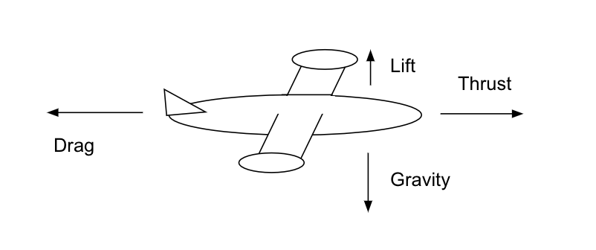

- The key components for rocket design are: thrust, aerodynamics, weight and guidance.
- Thrust can come from internal combustion or external force.
- The aerodynamic shape should include a nose cone and cylindrical body. As air passes over the rocket, it will take the path of least resistance. In addition, an aerodynamic design will decrease drag.
- For a given thrust, a lighter rocket will travel farther. Any weight must be properly distributed to maintain stability.
- Guidance (direction) and stability can be achieved by the fins. The fins, when properly aligned along the axis of the rocket, contribute to the stability of the rocket by maintaining a consistent direction. The student can use 3 fins (placed 120º apart) or 4 fins (placed 90º apart). The fins use wind resistance to maintain a straight course.
- When properly constructed, the rockets will follow a parabolic curve, called its trajectory, from launch to landing. The rocket is considered a projectile because it is an object (given an initial speed) moving through space. Its path is determined by gravity and wind resistance (drag). This projectile motion is a combination of positive horizontal and vertical motion (due to initial thrust) and negative vertical motion (due to gravity).
- A restoring force exists for this model rocket because the center of pressure is below the center of gravity.
- For a model rocket with maximum stability, the center of pressure must be located below the center of gravity.

Procedure
- Wrap sheet of card stock paper around PVC pipe, tape and remove from PVC pipe.
- Cut small circle from cardstock paper and cut small triangle out of the circle.

- 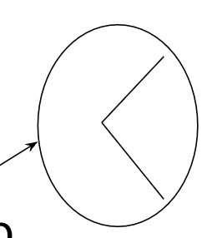

- Create a cone from circle and tape to top of paper tube.
- Cut 3 (or four) equal small triangles and tape to bottom of rockets equally spaced 120° (or 90°).
- Cut 2-18” pieces of PVC.
- Cut 6” of pipe insulator.
- Insert PVC pieces into either end of pipe insulator. This is your launcher. Make two launchers.
- Place rocket on launcher.
- Insert launcher into bottle.
- Aim rocket away from students.
- Have student jump on bottle to launch.

Wrap-up
End the lesson with some final discussions about what students designed/discovered. Connect their activity back to the focus question/problem, real world examples, and STEM careers.

Also include notes about any special cleanup considerations

Lesson Background for Teachers

Suggested Real-World STEM Connections
- List possible related Role Models in STEM (with details and links to more reading). Give suggestions for examples of scientists/engineers who are from underrepresented groups in STEM in related careers.
- List related real-world engineering problems and examples

Lesson Variations and Options
Include descriptions of alternative methods or ways to present things.

Explanation
Describe the background concepts and explanations behind the lesson. This can be more in depth than a teacher/instructor would actually share with students.

Key Concepts and Vocabulary
- Word 1: Grade Appropriate Definition
- Word 2: Grade Appropriate Definition

Safety Notes
- Safety instruction

